

Dear GradMatch team,

We are thrilled to announce the launch of an exciting new feature on GradMatch, our leading job matching platform. This feature was developed in response to the challenges faced by recent college graduates in finding relevant job opportunities that align with their skills and preferences.

Background:

As the demand for personalized job recommendations grew, we identified a significant problem in the job market. Recent graduates were struggling to discover the best job opportunities tailored to their unique profiles. We recognized the need to bridge this gap and empower our users with a solution that would revolutionize their job search experience.

Introducing the New Feature:

We are proud to present the enhanced recommendation engine on GradMatch. This cutting-edge feature utilizes advanced algorithms and machine learning techniques to analyze user profiles, skills, and preferences. By incorporating these insights, GradMatch now delivers highly personalized and relevant job recommendations to each individual user.

How it Solves the Problem:

With the new feature, our users can expect a more targeted and efficient job search process. The algorithm takes into account various factors such as industry, location, experience, and education to curate a list of job opportunities specifically tailored to their needs. This ensures that recent college graduates receive recommendations that truly align with their career goals and aspirations.

Data on Performance:

Since the introduction of the new feature, we are thrilled to share our exceptional results. In just a short span of 30 days, GradMatch has achieved over 10,000 downloads, with more than 1,000 final year students actively using our platform to reach their desired job. These remarkable numbers demonstrate the high demand and value our feature brings to the job-seeking community.

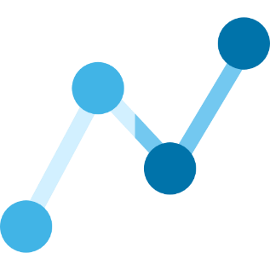

**10K+             1000+           4.2 rating**

Downloads Active users in App / Play Store

Next Steps:

As we celebrate this successful launch, our team remains committed to continuous improvement. We will closely monitor user feedback and iterate on the feature to further enhance its performance. We value your input and encourage you to share your thoughts and suggestions on how we can make GradMatch even better.

On behalf of the entire GradMatch team, I would like to express our gratitude for your support and trust in our platform. Together, we are transforming the job search landscape for recent college graduates and empowering them to achieve their career aspirations.

If you have any questions or need assistance, please don't hesitate to reach out to our dedicated support team. We are here to ensure a seamless experience for all GradMatch users.

Best regards,

Awoyomi Oluwademilade

PM

On behalf of the GradMatch Team